Hollywood Gender-Equity Advocates Call for Better Transgender Representation
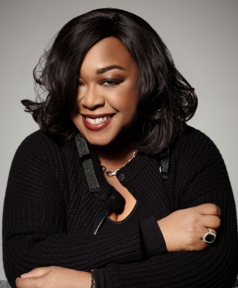
The Geena Davis Institute on Gender in Media along with numerous Hollywood actors, writers, directors, producers and other organizations such as Shonda Rhimes, Ryan Murphy, Jen Richards, J.J. Abrams and Rhys Ernst, have offered their support and excitement for the open letter published by Time's Up's 5050by2020 initiative and GLAAD, calling for equity for transgender people in the entertainment industry.
W Magazine online 8/7/18
https://www.wmagazine.com/story/hollywood-trans-representation-open-letter-reactions
Image credit:
http://www.nab.org/documents/newsroom/photos/SRHeadshot_hi.jpg

