Hospital Exec calls for Better Patient Engagement in Health Apps
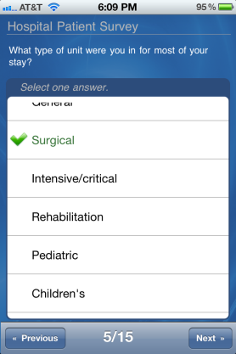
Hospitals should seek patient feedback on their health apps to boost engagement instead of developing broad, population-facing tools that may negatively affect the patient's experience, Cleveland Clinic Chief Experience Officer Adrienne Boissy said at the Pop Health Forum in Chicago.
MobiHealthNews.com 9/13/16
http://www.mobihealthnews.com/content/cleveland-clinic-exec-we-need-better-engagement-not-more-apps

