House Approves Expanded Media Access to Relief Funding
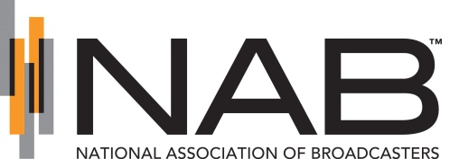
The House of Representatives has passed legislation that would allow local television and radio stations, as well as newspapers, access to federal assistance. "As local radio and TV stations and hometown newspapers struggle with historic advertising losses, it is critically important they have access to resources to support lifesaving journalism that keep families and communities out of harm's way," said Gordon Smith, CEO of the National Association of Broadcasters.
Inside Radio (free content) 5.18.20
http://www.insideradio.com/free/bill-that-would-help-struggling-broadcasters-passes-in-the-house/article_7ca8aed4-98dc-11ea-8aa3-37448b780163.html

