House GOP Introduces 3 Bills for Net Neutrality
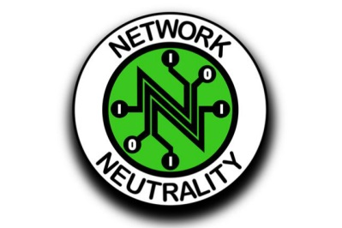
House Energy and Commerce Committee GOP members have introduced three bills focused on preventing throttling, blocking and paid prioritization, and they are asking their Democratic colleagues to consider the work a starting point for a bipartisan net neutrality resolution.
Broadcasting & Cable 2/21/19
https://www.broadcastingcable.com/news/house-gop-leaders-urge-engagement-on-net-neutrality-bills

