House Judiciary to Hold Online Censorship Hearing
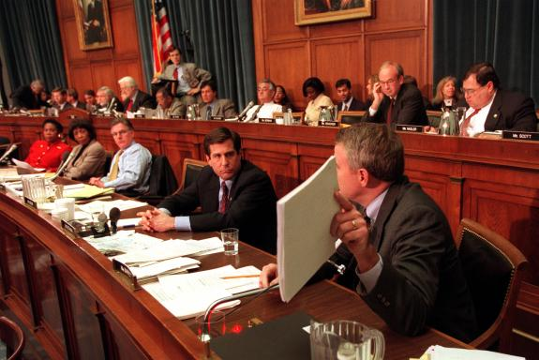
The House Judiciary Committee has scheduled a hearing on online censorship and whether social media platforms disfavor or favor certain speech. Invited are representatives of Facebook, Google and Twitter, though not word on whether any will show.
Broadcasting & Cable 4.24.18
https://www.broadcastingcable.com/news/house-judiciary-to-hold-online-censorship-hearing
Image credit:
http://2.bp.blogspot.com/-U-Qc0bkmhfw/TeE9QIg4SOI/AAAAAAAAOis/AMtFnWpa9nE/s1600/house+judiciary+committee.jpg

