House Votes to Reinstate Net Neutrality
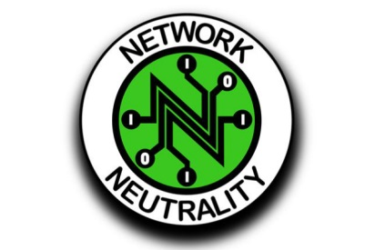
The Save the Internet Act passed the Democrat-controlled House 232-190 Wednesday, with only one Republican vote in favor. But top Senate Republican Mitch McConnell said Tuesday that net neutrality is “dead on arrival in the Senate.”
TVNewsCheck 4.11.19
https://tvnewscheck.com/article/top-news/233798/house-votes-to-reinstate-net-neutrality/?utm_source=Listrak&utm_medium=Email&utm_term=House+Votes+To+Reinstate+Net+Neutrality&utm_campaign=Marshall+Sues+Nexstar+Over+Station+Sales

