How AI is Transforming Digital Marketing
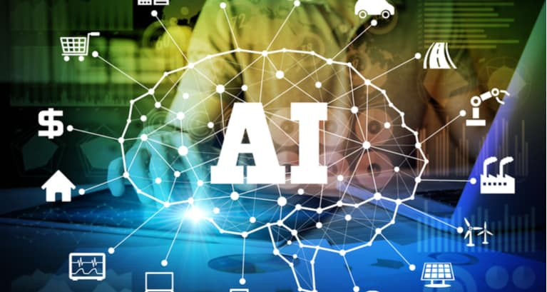
Artificial intelligence gives digital marketers a step up in creating an effective and personalized user experience, Chandan Bagwe writes. He highlights the ability of AI to predict behavior and discover new audiences.
Entrepreneur online 3/27/19
https://www.entrepreneur.com/article/331316
Image credit:
https://www.relevance.com/wp-content/uploads/2018/03/Impact-of-Artificial-Intelligence-on-Digital-Marketing.jpg

