How Brands Are Maximizing User-Generated Content
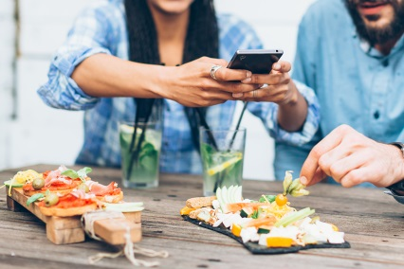
Brands are increasingly engaging with popular user-generated content on social media to connect to audiences who don't like sponsored content. Infinite Objects, Little Bellies and Trek Bikes are among brands that are expanding reach through UGC on platforms like TikTok and Instagram and encouraging fans to share it with playful hashtag campaigns and contests.
Adweek 9.14.21
https://www.adweek.com/brand-marketing/brands-must-embrace-user-generated-content/
Image credit:
https://cmxhub.com/wp-content/uploads/2019/02/7-Examples-of-Awesome-User-Generated-Content-Campaigns.jpg

