How ICIJ got Hundreds of Journalists to Collaborate on the Panama Papers
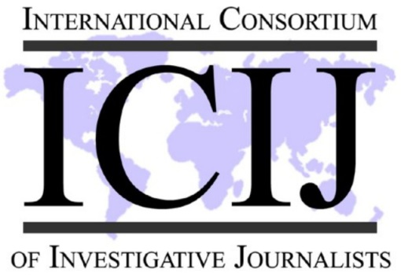
The latest collaborative investigation from the International Consortium of Investigative Journalists includes a lot of ingredients. Among them: More than 370 journalists in more than 80 countries at more than 100 media organizations. "I think that the publishing together creates a critical mass," Mike Hudson, senior editor at ICIJ said, "just this incredible firestorm of attention."
Poynter 4.4.16
http://www.poynter.org/2016/how-icij-got-hundreds-of-journalists-to-collaborate-on-the-panama-papers/405041/?utm_source=API+Need+to+Know+newsletter&utm_campaign=e3a17650b8-Need_to_Know_April_5_20164_5_2016&utm_medium=email&utm_term=0_e3bf78af04-e3a17650b8-31697553

