How Many Gen Xers Use Wearables?
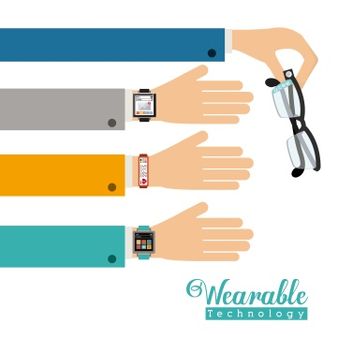
By the end of 2018, 15.4 million Gen Xers will have used a wearable device at least once per month, up from 14.0 million in 2017. "Gen Xers have more income than millennials. But they also have more demands on their money—mortgages, expenses for kids, saving for retirement," said eMarketer senior analyst Mark Dolliver.
eMarketer 12.19.18
https://www.emarketer.com/content/how-many-gen-xers-use-wearables?ecid=NL1001
Image credit:
https://mobileidworld.com/assets/57132772_thumbnail.jpg

