How Maybelline is Beating Beauty Rivals on Social
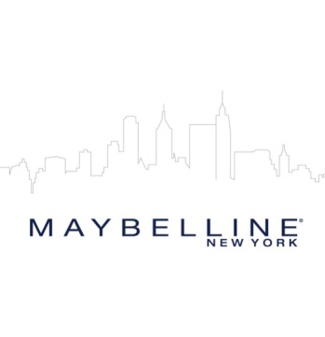
Maybelline is outperforming parent company L'Oreal on social media engagement, along with rivals Revlon and Estée Lauder, for example garnering 59 million Instagram likes from Jan. 1 to Oct. 20 compared with 27 million and 5 million respectively for L'Oreal and Estee Lauder, ShareIQ reports.
Glossy 11/7/17
http://www.glossy.co/new-face-of-beauty/why-maybelline-is-winning-at-social-media

