How NBC Uses Social Media to Woo Football Fans
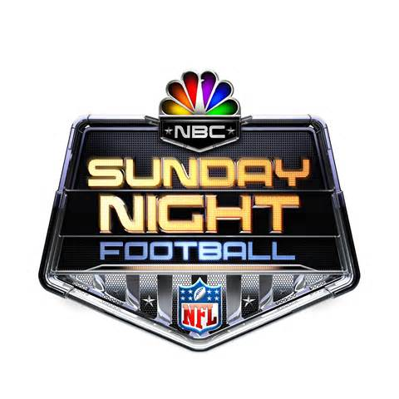
The network uses video on social media to lure viewers, plus Twitter updates and player-created videos to celebrate performances during the game. "We want to entice people to watch. But we also want to have fun and reach a broader audience, where it's not always X's-and-O's football content," said NBC Sports' social media director, Lyndsay Signor.
Digiday.com 10/12/15
http://digiday.com/publishers/inside-nbcs-sunday-night-football-social-media-touchdown/

