How Ocean Spray Demonstrates Social Savvy
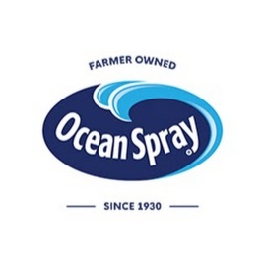
Ocean Spray demonstrated social savvy by turning a customer's TikTok video into a viral sensation, while Sherwin Williams fell short for firing an employee who posted online content using its paints. Ocean Spray reaped rewards in terms of impressions and positive media stories while Sherwin Williams "is stiff-arming a clear opportunity to generate awareness and engagement most brands would die for," writes Hanson.
ACH Communications 11/24/20
http://www.arikhanson.com/2020/11/24/ocean-spray-and-sherwin-williams-a-tale-of-2-companies-and-how-they-embrace-social-media/

