How Pandemic is Shaping Influencer Content
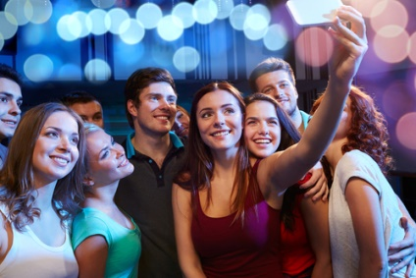
A study from Fullscreen reveals 34% of those in the age range of 18 to 34 years old are watching more content from influencers during the pandemic. "We're witnessing a new level of 'real' with influencer content right now," says Fullscreen's Chris Bower, adding, "We will also see new types of creators emerging -- including a broader diversity of influencers -- all sharing from their own experience and perspective."
Forbes 6.14.20
https://www.forbes.com/sites/johnscottlewinski/2020/06/14/media-looking-beyond-covid-19-for-the-future-role-of-influencers/#19d242837cae
Image credit:
https://lastingrecovery.com/wp-content/uploads/2017/01/sober-party.jpg

