How Social Media is Changing the Beauty Industry
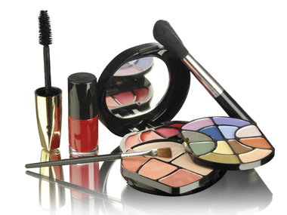
Social sharing is making the beauty industry a more inclusive and far-reaching retail sector, analysts say. Brands that are thriving in retail know how to create buzz and how to bridge between online and offline communities, analysts say. "These are the brands that are leading the charge today, and a lot of it is things they are doing to inform the consumer through their social-media work," says Karen Grant of NPD Group.
Refinery29 12/19/15
http://www.refinery29.com/2015/12/99728/beauty-industry-social-media-effect

