How Social Media Use is Evolving
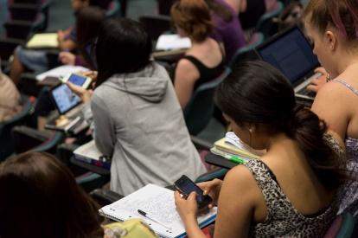
Almost 79% of consumers are somewhat or very worried about information privacy on social media, and just over 82% censor themselves, finds a survey by The Atlantic. Facebook was the least-trusted social platform, despite also being the most widely used.
The Atlantic online 6/7/18
https://www.theatlantic.com/technology/archive/2018/06/did-cambridge-analytica-actually-change-facebook-users-behavior/562154/
Image credit:
http://app.griffith.edu.au/news/wp-content/uploads/2013/03/kids-with-mobiledevices.jpg

