Infographic: How Super Bowl Fans Consume Social Media
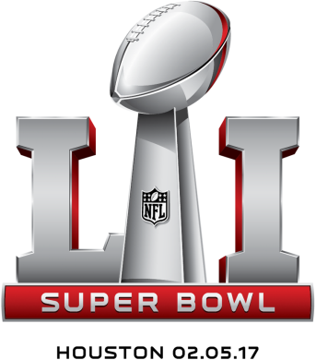
Forty-nine percent of Super Bowl viewers expect to look at Facebook during the game, while 26% will look at Instagram and 22% will turn to Twitter, an infographic from Survata and Adweek shows. Twenty-eight percent said they liked to see teasers of ads on social before the game, while 36% said they preferred to be surprised by the ads on the day of the game.
Adweek 1/29/17
http://www.adweek.com/digital/a-look-at-all-the-ways-fans-will-use-social-media-during-the-super-bowl/

