How T-Commerce Could Benefit From Next Gen TV
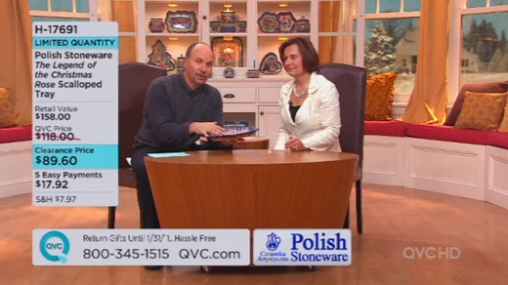
Next-generation broadcasting could help transform TV-based shopping, making t-commerce "so simple that even logging onto Amazon would feel like a drag," Diana Marszalek writes. The National Association of Broadcasters recently teamed up with HSN on a prototype for making TV purchases, with Nextstar Media Group's Brett Jenkins noting, "There is no question that ATSC 3.0 was designed for that kind of interactivity."
Multichannel News 8/14/17
http://www.multichannel.com/next-generation-tv-expected-usher-new-era-t-commerce/414558
Image credit:
http://permanence.com/roku/images/tvshopping_ss_qvc.jpg

