How to Connect With Generation Alpha
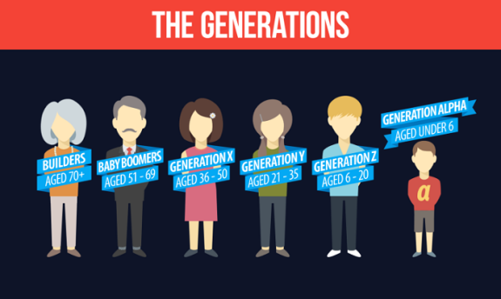
Generation Alpha -- individuals born between 2010 and 2025 -- are becoming the next wave on US consumers, writes Stephen Dupont, APR. He outlines a series of strategies that communications pros can implement to engage with this mobile-dependent generation and urges execs not to "mistake Generation Alpha for an extension of Gen Z or the millennials," but instead compares them to the generation that "lived through the Depression and World War II."
Strategies & Tactics 12/2019
https://www.prsa.org/article/here-comes-generation-alpha
Image credit:
https://2.bp.blogspot.com/-vnCLpm16USc/V81cBkOnF7I/AAAAAAAAI24/bjqYS221w0onV9O_gFnAxdVwTWm-n_QZgCLcB/s1600/TheGenerations.png

