How To Craft An Apology That Won't Backfire
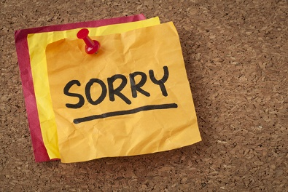
Communications executives charged with issuing apologies need to avoid knee-jerk reactions and come off sounding as insincere, writes Amanda Staggenborg, George Fox University's assistant professor of public relations. Staggenborg offers several questions to ask yourself before issuing "a poor, ill-worded apology that you'll later have to apologize for."
PR Daily 2/11/22
https://www.prdaily.com/why-and-how-pr-pros-should-beware-apology-fatigue/

