IAB Announces NewFronts Slate, Adds Streaming Sessions
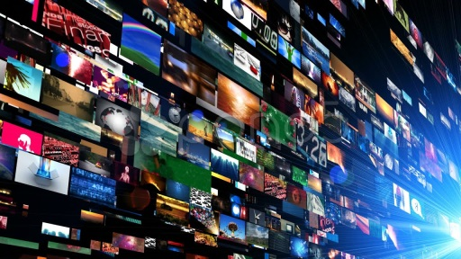
IAB is expanding its weeklong NewFronts to include sessions focused on the streaming business, with the entire event including at least 14 presentations from platforms and publishers over eight days, April 27 to May 6. Presenters scheduled include Amazon, Hulu, BBC News, Conde Nast, Meredith, The New York Times, Twitter, Verizon Media and Vice, and session topics also will include influencer marketing and audio.
Tubefilter 2.28.20
https://www.tubefilter.com/2020/02/28/iab-reformats-newfronts-audio-influencers/
Image credit:
https://i.ytimg.com/vi/ML20mtoalE0/maxresdefault.jpg

