IAB Calls for Federal Privacy Law
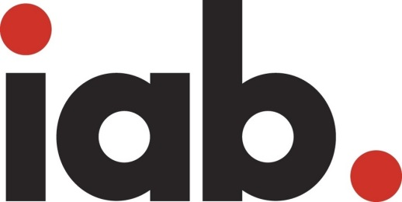
The Interactive Advertising Bureau has changed its stance on government intervention in privacy legislation to prevent a fragmented state approach, which could be encouraged by California's new law. "A uniform federal privacy standard could provide clarity, market certainty, and add fuel to future innovation, while preserving the value and benefit that online advertising brings to the internet ecosystem," wrote the IAB's David Grimaldi in a letter to Senate Commerce Committee leaders.
MediaPost Communications 9/24/18
https://www.mediapost.com/publications/article/325546/in-reversal-iab-says-congress-should-consider-pri.html

