IAB Part of Collective Addressing Online Hate Speech
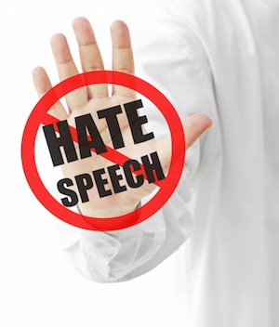
Global Alliance for Responsible Media members say they are looking to "better define hate speech" after such content on social platforms has been in the spotlight. GARM includes associations like the IAB, the Association of National Advertisers and tech and media firms such as Procter & Gamble, Unilever, Facebook, Twitter and Google/YouTube. Spokespeople for YouTube and Twitter say they support GARM's mission.
Axios 7/17/20
https://www.axios.com/advertising-hate-speech-tech-companies-facebook-5d2b4ebf-e412-4075-ad1f-77aa2b7a07b3.html
Image credit:
https://www.ipwatchdog.com/wp-content/uploads/2016/06/stop-hate-speech.jpg

