IAB Playfronts Highlights
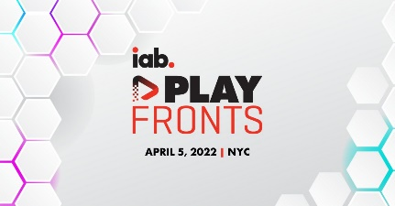
"Just as mobile was initially slow to monetize until advertisers could no longer ignore the shift of consumer time and attention ... so too, will advertisers eventually unlock the power of gaming as a marketing channel," said Zoe Soon, vice president of IAB's experience center.
Marketing Dive 4/6/22
https://www.marketingdive.com/news/gaming-advertising-marketing-Roblox-Fortnite-commerce/621675/

