If Netflix Were a TV Network, It’d Be Tops
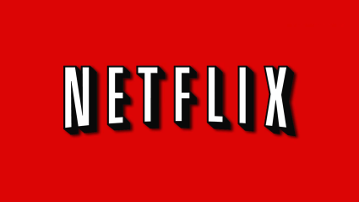
Speaking at the Institute for International Research’s Media Insights & Engagement Conference, Turner chief research officer Howard Shimmel said that based on the company’s methodology, Netflix was the No. 1 rated TV network in total day in the U.S. in the fourth quarter of 2015. That means that at any given time of day, Netflix is averaging more viewers than any broadcast or cable network.
MediaLife 2.17.16
http://www.medialifemagazine.com/wow-the-top-tv-network-is-netflix/

