Imagine, the End of the Network as We Know It
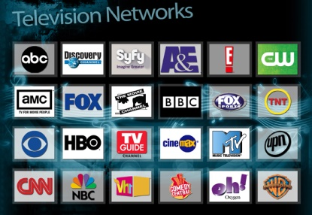
Eventually we may come to a day when the very concept of networks all but disappears, according to a new report from Barclays Capital on the future of media. It’s a prediction that would have a huge impact on media buying and planning. “The concept of a ‘network’ could become obsolete,” observes the report. “The report predicts that content will become divided into two main buckets: scripted shows and live events.
MediaLife 3.17.16
http://www.medialifemagazine.com/imagine-a-world-without-the-networks/

