LeGeyt Predicts Change Will Come From In-Dash Screens
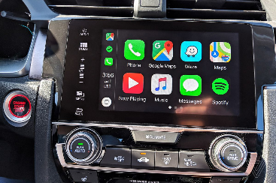
The growing prevalence of video screens in vehicle dashboards will drive radio's "screenification" as broadcasters bundle content in multiple formats, although radio's focus on live programming and local hosts will persist, National Association of Broadcasters CEO Curtis LeGeyt says. Lawmakers must enact protections for broadcasters serving the American public as they work to compete against technology giants, LeGeyt adds.
Inside Radio (free content) 7/6/22
https://www.insideradio.com/free/nab-s-legeyt-sees-radio-evolving-into-screen-driven-experience/article_90febf7a-fcf0-11ec-bb62-7f91c509029d.html
Image credit:
https://cdn.vox-cdn.com/thumbor/itCM8Yx3RV2tjQ1JZj-CVWa95t0=/0x0:2040x1360/1200x800/filters:focal(857x517:1183x843)/cdn.vox-cdn.com/uploads/chorus_image/image/65286699/vpavic_180925_2980_0007.0.jpg

