What In-Game Ad Formats Players Prefer
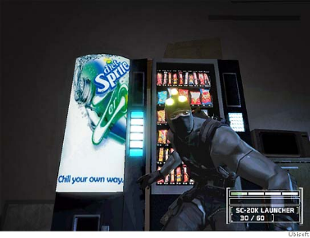
In-game intrinsic ads that don't interrupt gameplay causes 34.1% of players to take action, followed by interstitial (27.2%), adjacent (24.1%) and audio (15.3%), while 27.1% are not moved by any format, per a Frameplay survey. Some 45% say they primarily see interstitial ads and 22.8% identify the intrinsic format as dominant.
MarTech Today 11.1.22
https://martech.org/survey-finds-gamers-prefer-native-and-interstitial-ads/
Image credit:
https://s.hdnux.com/photos/12/11/20/2659380/6/rawImage.jpg

