Indiana Cities Sue Streamers Over Cable Franchise Fees
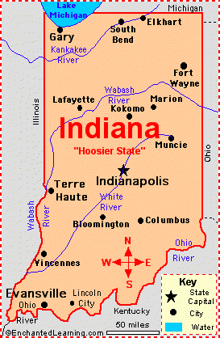
A group of Indiana cities, Indianapolis among them, are trying to collect 5% franchise fees under the 2012 Video Service Franchise Act by suing Disney+, Hulu, DIRECTV and DISH Network in a state court. The cities, which also include Evansville, Valparaiso and Fishers, assert that the streaming and satellite companies use public rights of way to distribute their services.
Next TV 8.17.20
https://www.nexttv.com/news/netflix-hulu-disney-sued-by-indianapolis-to-collect-5-cable-franchise-fee
Image credit:
http://www.enchantedlearning.com/usa/states/indiana/map.GIF

