Indonesian Telecom Provider Blocks Access to Netflix
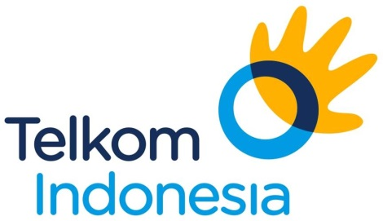
Indonesia's state-owned telecommunications company says it has blocked the Internet video service Netflix in a possible setback to the U.S. company's expansion in Asia. PT Telekomunikasi Indonesia said in a statement it blocked Netflix beginning Wednesday because it lacks a permit to operate in Indonesia. The service was still available Thursday via other network operators.
The Associated Press 1.28.16
http://www.tvnewscheck.com/article/91885/indonesian-telecom-provider-blocks-access-to-netflix?utm_source=Listrak&utm_medium=Email&utm_term=Indonesian+Telecom+Provider+Blocks+Access+To+Netflix&utm_campaign=Sinclair+Buying+Tennis+Channel+For+%24350M+

