IAB, 4A's and ANA Push for Industry-Led Ban on Poor Ads
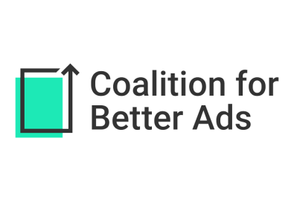
The Interactive Advertising Bureau, the American Association of Advertising Agencies and the Association of National Advertisers have written to the Coalition for Better Ads to urge that the industry adopt a self-regulatory framework to stop the use of digital ad formats known to provide a bad consumer experience. "The Better Ads Experience Program" would eliminate the use of four desktop and eight mobile ad units that coalition research indicates consumers find "annoying, interruptive or obstructive."
MediaPost Communications 10/12/17
https://www.mediapost.com/publications/article/308673/ana-4as-and-iab-include-browsers-in-self-regulato.html

