Influencers Want a True Partnership with Brands
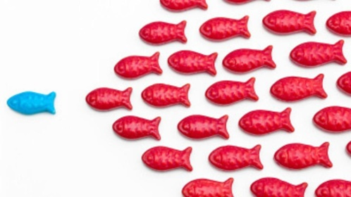
Eighty-five percent of influencers say they will take part in more branded campaigns next year and 77% work with brands on ongoing campaigns, according to Julius. More than 63% said the top reason they rejected a brand was concerns about content control.
The Drum (Glasgow, Scotland) 12/13/16
http://www.thedrum.com/news/2016/12/13/influencers-seek-authenticity-and-collaboration-with-brands-their-roles-evolve-and
Image source:
https://sellorelse.ogilvy.com/wp-content/uploads/2014/04/how-to-jump-start-your-career-by-becoming-an-online-influencer-99596ccbf5-1.jpg

