Infographic: Employee Advocacy Program Best Practices
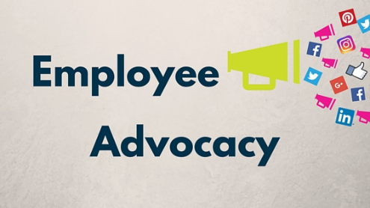
PAN Communications highlights steps to establish an employee advocacy program that includes eliciting staff buy-in, establishing a structured approach to social sharing and demonstrating the benefits for the business and the individual. A robust internal culture with marketing and human resources collaborating to advance the employee program can broaden the customer base, boost revenues, shorten sales cycles and yield lower acquisition costs, according to PAN Communications.
Social Media Today 8.1.21
https://www.socialmediatoday.com/news/the-power-of-employee-advocacy-and-how-to-establish-your-ea-program-infog/604246/
Image credit:
https://businessfirstfamily.com/employee-advocacy-program-benefits/

