Inside the Slow Death of Cable TV
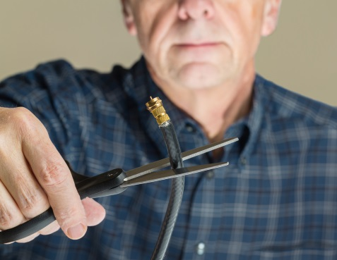
Ohio-based MCTV is one of a number of small and midsize cable operators that have thrown in the towel when it comes to trying to hang on to television subscribers in a cord-cutting universe. The company’s profit margin on its TV service has fallen by nearly half in recent years. Consequently, MCTV is now focused largely on providing broadband service.
Variety 4.11.19
https://variety.com/2019/biz/features/traditional-cable-companies-1203183710/
Image credit:
http://mediashift.org/wp-content/uploads/2017/10/cord-cutting.jpg

