Don't Be Shy With Instagram Hashtags
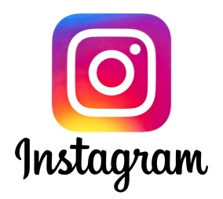
Analysis of over 18 million feed posts on Instagram by Later reveals that posts accompanied by 20 hashtags achieve the highest reach and those with 30 hashtags generate the most comments and likes. The research goes against Instagram's own advice of using between three and five hashtags and it might be worth testing posts with higher numbers, Andrew Hutchinson writes.
Social Media Today 11/19/21
https://www.socialmediatoday.com/news/new-study-looks-at-optimal-hashtag-usage-in-instagram-feed-posts-based-on/610377/

