5 Ways To Maximize Instagram Influencer Efforts
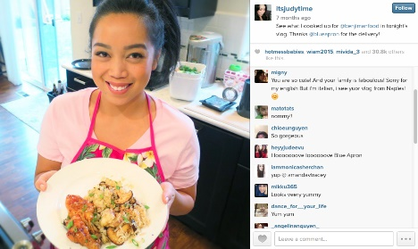
Rafaella Aguiar outlines five steps to get started with Instagram influencer efforts, including vetting brand ambassadors with various follower counts to find the right brand fit and budget and establishing goals such as reach and awareness.
Business 2 Community 8.22.21
https://www.business2community.com/instagram/5-amazing-hacks-to-take-instagram-influencer-marketing-to-the-next-level-02426897
Image credit:
https://mediakix.com/wp-content/uploads/2015/06/Instagram-Influencer-Its-Judy-Time-For-Blue-Apron-.png

