Instagram Introduces AR Shopping Feature
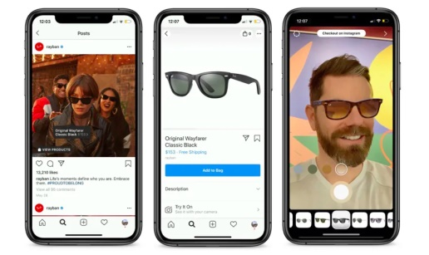
Instagram is trialing an augmented reality try-on shopping experience with MAC Cosmetics, Ray-Ban, NARS Cosmetics and Warby Parker, which is expected to be rolled out more widely in the future. The feature allows users to virtually try on products shown within the brands' Stories, profile pages or feed posts and purchase directly via the app's checkout as well as share recommendations with friends through Stories and Direct messages.
Mashable 10/3/19
https://mashable.com/article/instagagram-adds-augmented-reality-shopping/
Image credit:
https://mk0laterblog4vkmxupe.kinstacdn.com/wp-content/uploads/2019/10/Screen-Shot-2019-10-04-at-5.19.37-PM.png

