Designing People’s Instagram Stories is Now a Million-Dollar Business
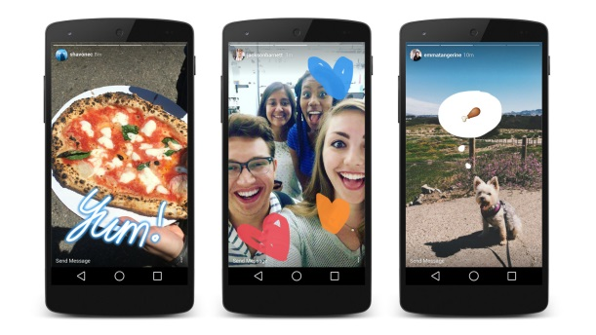
With that immediacy has come a pressure to seem cool and spontaneous all the time. It’s also a challenge for brands that use Stories to advertise; companies need to produce fun, current content on a daily basis, and manage those Stories the same way they manage their permanent content elsewhere online–even if it quickly disappears.
Fast Company 11.5.18
https://www.fastcompany.com/90259515/inside-the-big-business-of-instagram-story-design?utm_source=API+Need+to+Know+newsletter&utm_campaign=7d9861bcf4-EMAIL_CAMPAIGN_2018_11_05_12_44&utm_medium=email&utm_term=0_e3bf78af04-7d9861bcf4-31697553
Image credit:
https://marketingland.com/wp-content/ml-loads/2016/08/Instagram_StoriesWatch-1920.jpg

