Instagram Takes Steps Against "Potentially Harmful" Posts
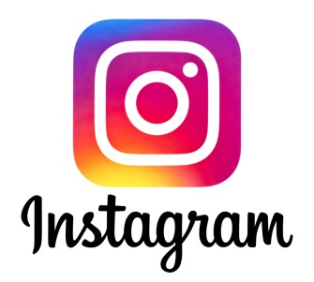
Instagram's algorithm will now make "potentially harmful" posts less visible by comparing them to content that the platform has previously removed and moving them lower in people's feeds, as well as changing individuals' algorithms based on posts they've reported in the past. The new development could catch hate speech, incitements to violence or bullying posts before they reach the moderators.
Engadget 1/21/22
https://www.engadget.com/instagram-will-down-rank-potentially-harmful-content-in-feed-and-stories-004411923.html

