IAB: Internet-Enabled TVs are Now the Norm
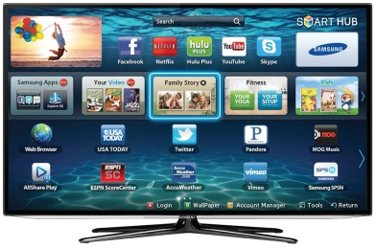
Most Americans -- about 56% -- now own a TV that can stream digital video, and those who do are streaming content 24% of the time while watching live TV 39% of the time, an online study from the IAB and MARU Matchbox has found. It also notes that half of Internet-enabled TV owners prefer ads to subscription-based content and 44% say digital video ads are not as intrusive as traditional TV ads.
Recode 5/10/17
https://www.recode.net/2017/5/10/15611654/americans-watching-tv-streaming-online-video
Image credit:
http://hd-report.com/wp-content/uploads/2013/10/samsung-6100-Smart-TV.jpg

