IDC: Expect Fast Growth in Internet of Things This Year
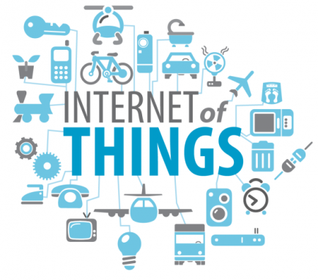
The rapid adoption of digital signage in retail will help drive 19% growth in the Internet of Things consumer and enterprise markets this year, IDC predicts. The fast- growing IoT space is expected to expand from $42.2 billion in 2013 to $98.8 billion in 2018.
Information Week 5.20.15

http://www.informationweek.com/it-life/iot-market-will-grow-19-percent-in-2015-idc-predicts/d/d-id/1320500

