iPhone 12 Will Supercharge Mobile AR in 2021
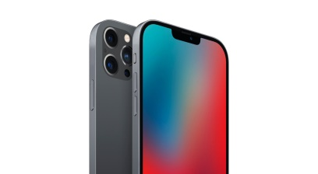
Before the iPhone 12 was released, AR advertising grew from about half a billion dollars in global revenues in 2019 to $1.41 billion this year, according to information from AR research firm ARtillery Intelligence. Driven by social media advertising, such as Snapchat Lenses—and strong results for brand advertisers—that figure should surpass $8 billion by the end of 2024.
eMarketer 12.30.20
https://www.emarketer.com/content/iphone-12-will-supercharge-mobile-ar-2021?ecid=NL1001
Image credit:
https://cdn.wccftech.com/wp-content/uploads/2020/05/iPhone-12-5.jpg

