Is it OK to Exploit Poor Indians in the Name of Photojournalism?
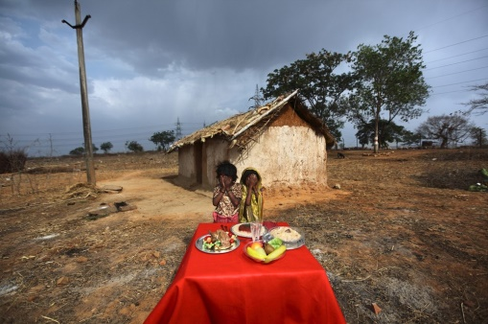
In the series, villagers in Madhya Pradesh and Uttar Pradesh are shown with their hands covering their faces, standing before a table laden with plates of what looks like spaghetti Bolognese, perfect-looking fruit, and even a roasted chicken—all fake, and all dishes they are unlikely to have ever seen before.
Quartz 7.24.18
https://qz.com/1334792/world-press-photo-controversy-over-alessio-mamos-images-of-indians/?utm_source=API+Need+to+Know+newsletter&utm_campaign=25caa313ea-EMAIL_CAMPAIGN_2018_07_26_12_20&utm_medium=email&utm_term=0_e3bf78af04-25caa313ea-31697553
Image credit:
https://dd978y4vwod92.cloudfront.net/uploads/photos/images/347886/b488bcb3d894699088996f443faef6f0-large.jpg?1416172154

