It’s so Dangerous Being a Bridesmaid in China
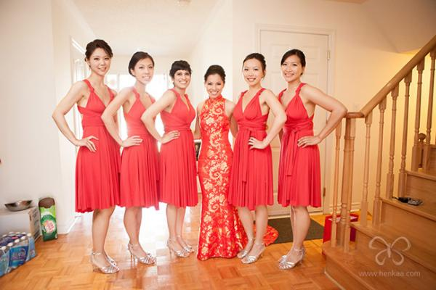
From commoners to renowned celebrities, Chinese bridesmaids are vulnerable to verbal harassment as well as physical and sexual abuse. Video footage went viral on the Chinese internet showing groomsmen attempting to dump Liu Yan, a famous Chinese actress, into a swimming pool when she was a bridesmaid at her friend’s wedding.
Quartz 10.26.16
http://www.msn.com/en-us/news/world/it%e2%80%99s-so-dangerous-being-a-bridesmaid-in-china-that-some-brides-are-hiring-professionals-instead/ar-AAjoU6y?li=BBnb7Kz&OCID=msnHomepage

