'Jersey Shore' Revived at MTV with Original Cast
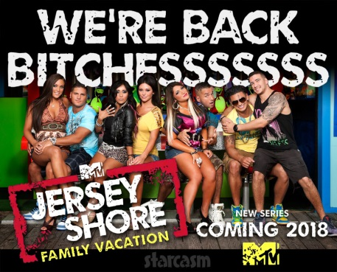
Five years after MTV's Jersey Shore closed up shop, the breakout reality hit is returning to the Viacom-owned cable network. MTV on Monday announced that it is reviving the show with a new take, Jersey Shore Family Vacation, featuring several of the franchise's original personalities.
The Hollywood Reporter 11.28.17
https://www.hollywoodreporter.com/live-feed/jersey-shore-revived-at-mtv-original-cast-1061931
Image credit:
http://starcasm.net/wp-content/uploads/2017/11/Jersey_Shore_Family_Vacation_fin.jpg?ggnoads

