Reporters Without Borders: Journalism at Tipping Point
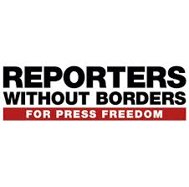
"Attacks on the media have become commonplace and strongmen are on the rise. We have reached the age of post-truth, propaganda, and suppression of freedoms - especially in democracies," the report said. "Media freedom has never been so threatened."
World Press Freedom Index AlJazzera 4.26.17
http://www.aljazeera.com/news/2017/04/reports-borders-journalism-tipping-point-170426055328722.html?utm_source=All+Poynter+Subscribers&utm_campaign=021cce468e-EMAIL_CAMPAIGN_2017_04_27&utm_medium=email&utm_term=0_5372046825-021cce468e-257931389

