CPJ Highlights Capitol Riot's Impact On Journalists
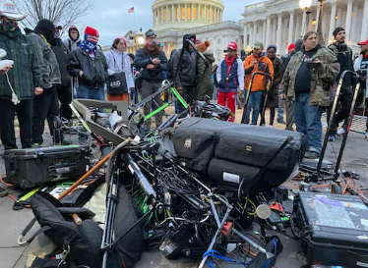
Last year's attack on the U.S. Capitol resulted in the assault of 18 journalists and caused thousands of dollars in equipment damages during the Capitol riot on Jan. 6, 2021, the Committee to Protect Journalists reports. The CPJ recently issued a statement reminding the public of journalists' efforts to inform the public during the riots and the price they paid as a result.
Next TV/Broadcasting+Cable 1/6/23
https://www.nexttv.com/news/cpj-journalists-paid-price-for-january-6-coverage?utm_term=A25693A1-51B6-4112-BDE4-56BD420E983F&utm_campaign=45863C53-9E40-4489-97A3-CC1A29EF491D&utm_medium=email&utm_content=B934720D-0F23-46E1-ADF4-90ED2058574C&utm_source=SmartBrief

https://cpj.org/2021/01/three-people-threatened-to-shoot-me-journalists-describe-covering-mob-violence-at-the-us-capitol/
Image credit:
https://images.theconversation.com/files/377643/original/file-20210107-20-1lpao28.jpg?ixlib=rb-1.1.0&rect=1%2C19%2C1020%2C746&q=45&auto=format&w=496&fit=clip

