Journalists' Memorial Gets Green Light From Lawmakers
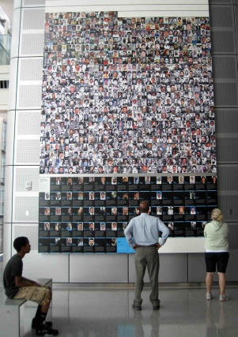
Journalists killed in the course of bringing news stories to the public will receive a Washington, D.C., memorial within roughly seven years. The Senate approved the Fallen Journalists Memorial Act on Dec. 2, and advocates think President Donald Trump will sign it, authorizing planning and fundraising for the monument's construction.
Capital Gazette (Annapolis, Md.) 12.3.20
https://www.capitalgazette.com/politics/ac-cn-fallen-journalists-memorial-20201203-20201203-mdyxgflainh55mtye7f6rjywra-story.html
Image credit:
http://1.bp.blogspot.com/-gOSQ0Jxl1_k/UBMvTf4OKcI/AAAAAAAAJQ8/Ob2R0aIMoCY/s1600/Newseum91.jpg

