Judge Clears Way for T-Mobile, Sprint to Merge
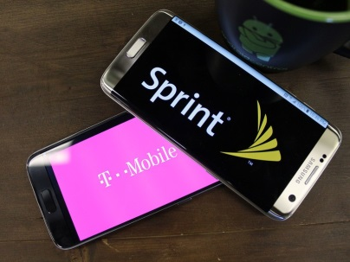
A federal judge upheld T-Mobile's $26 billion merger plans with Sprint clearing the way for the combined company to become the nation's third-largest wireless carrier with more than 100 million subscribers. Judge Victor Marrero rejected the state attorneys general's arguments that the merger would lead to anticompetitive behavior.
CNBC 2.11.20
https://www.cnbc.com/2020/02/11/sprint-soars-after-judge-approves-its-merger-with-t-mobile.html
Image credit:
https://www.androidcentral.com/sites/androidcentral.com/files/styles/large/public/article_images/2016/04/wireless-carriers-t-mobile-vs-sprint-hero.jpg?itok=51XpCS_Y

