Judge OKs AT&T-Time Warner Merger
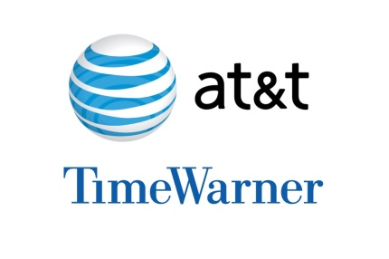
A federal judge approved the $85 billion mega-merger of AT&T and Time Warner on Tuesday, a move that could usher in a wave of media consolidation while shaping how much consumers pay for streaming TV and movies. The judge said the government failed to prove that the merger would lead to higher prices and other ham to consumers.
The Associated Press 6.12.18
http://www.tvnewscheck.com/article/114276/judge-oks-atttime-warner-merger?utm_source=Listrak&utm_medium=Email&utm_term=Judge+OKs+AT%26amp%3bT-Time+Warner+Merger&utm_campaign=Scripps%3a+TV+News+Needs+To+Break+Bad+Habits
Image credit:
https://s4827.pcdn.co/wp-content/uploads/2018/06/ATT_Time_Warner_logos_banner.jpg

